Unraveling DNA Damage-Induced Ageing Mechanisms through Transcriptomic Analysis

BACKGROUND
Ageing is a complex biological process driven by cumulative molecular damage, among which DNA damage and impaired repair pathways play a central role. Deficiencies in nucleotide excision repair proteins, such as ERCC1-XPF, accelerate ageing phenotypes in both humans and progeroid mouse models. However, the molecular mechanisms linking DNA repair failure to tissue-specific ageing responses remain incompletely understood. By integrating transcriptomic datasets from DNA-repair-deficient and naturally aged models, this project aims to identify key genes and pathways involved in DNA damage-induced ageing, offering new insights into genomic instability and longevity regulation.

AIMS AND OBJECTIVES
The primary aim is to investigate how DNA repair deficiency contributes to ageing at the transcriptomic level through the identification of differentially expressed genes (DEGs) and pathway alterations.
Specific Objectives:
- Retrieve and curate public transcriptomic datasets (GSE206778 and complementary GEO datasets) involving DNA repair-deficient and naturally aged models.
- Perform quality control, normalisation, and differential expression analysis to identify genes altered during ageing and DNA repair loss.
- Map DEGs to biological pathways using functional enrichment tools to uncover ageing-related molecular signatures.
- Incorporate a machine learning (ML) layer: using clustering and feature selection algorithms, to classify tissues or age groups based on gene expression and identify potential biomarkers of ageing.
- Integrate findings into a systems-level model connecting DNA repair deficiency to ageing mechanisms.

Proposed Methodology
Public RNA-seq and microarray datasets will be retrieved from the NCBI GEO and ArrayExpress databases using GEOquery and Bioconductor tools. Preprocessing (normalisation, outlier detection, and filtering) will be conducted in R using DESeq2 or limma. Differentially expressed genes (DEGs) will be identified between DNA repair-deficient, aged, and control samples. Annotation and pathway enrichment will be performed using AnnotationDbi, clusterProfiler, and ReactomePA.

A machine learning framework will be applied to uncover discriminative expression patterns. A Random Forest classifier will be trained to distinguish between experimental groups, and the model’s feature importance will be used to rank genes by their contribution to predictive accuracy. The top-ranked genes will be compared with DEGs and enriched pathways to identify robust molecular biomarkers of DNA damage-induced ageing.

All analyses will be implemented and version-controlled in R and GitHub. Final deliverables include. A detailed project report, a scientific poster, and an optional short video summarising the workflow and findings.

Workflow Diagram:
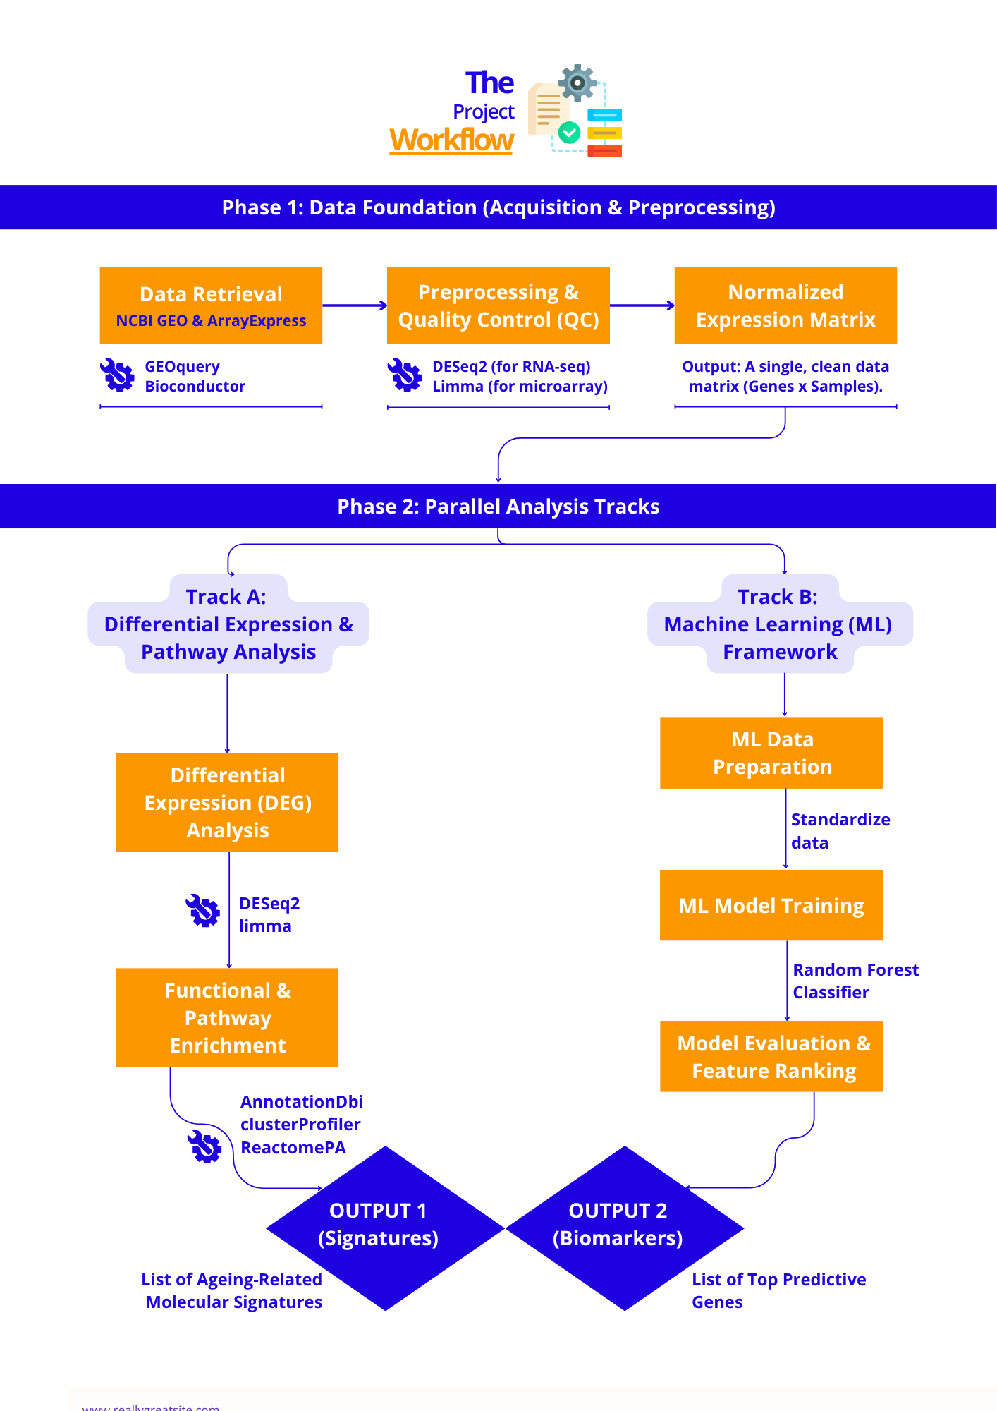

Group Details:
Name | Discord Username | Role
Hasmik Chilingaryan | mik0yan | Group Leader (All)
Swati | swati_29 | Visualisation (Figures), Coder
James Joy | joyjames0778 | Research (Literature & Data), Writer
Temitope Ayano | temiayano | Visualisation (Figures), Bioinformatics
Oluwasemilogo Akinlo | sems0396_19481 | Research (Literature), Writer
Gloria | asuna4_ | Research (Literature), Writer
Pavithra | pavithra0067_84434 | Research (Literature), Writer
Deborah | ade_debbie | Research, (Final Project Report), Coder
Abeer Ali | abeer_ali_ | Research (Literature & Data), Writer
Andrew | andronicus_11202 | Research (Literature & Data), Writer
Randy | randy091754 | Research (Literature), Writer

